(1 mark, file to be edited: Q5.c)
Write a program that includes the function int sumOdd(int *arr, int n, int *found) which allows users to enter an array of n integers (where n is entered by the user and n > 0). The program should calculate and print the sum of all odd numbers in the array. If there are no odd numbers in the array, the program should print: “There are no odd numbers in n elements.”
Below is an example:

Test case 1:
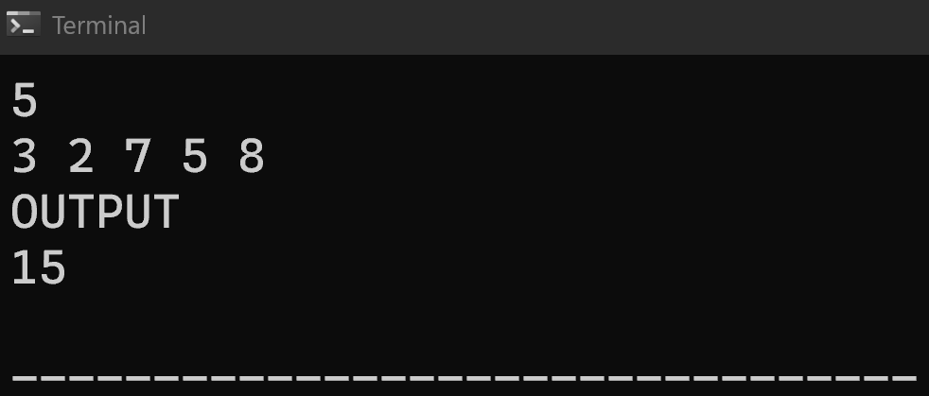
Test case 2:

